Learning Together # 1: (Christian) Spirituality, part 4
In the last part of this resource material for discussion around spirituality I, Bruce, suggested that communication is a core element of Christian spirituality. I expressed the view that communication was an outworking of three major distinctives of the Christian faith, namely the Trinity (God is a loving community in perfect harmony); the Incarnation (Jesus came to live on earth as a human being) and Forgiveness (God is actively working to address wrong and to make a better world). You, of course, are entitled to a different view and are welcome to share it at our next Gathering on the 17th March! I then outlined a number of ways in which we can communicate with God and directed people to a reference book (Adele Calhoun’s Spiritual Disciplines Handbook; IVP, Downers Grove, 2005) if they wanted to explore those or a number of other spiritual practices.
Interpersonal Communication:
It’s my understanding that Christian spirituality is not just about one’s relationship with and connection to God. The Christian Scriptures explains quite clearly that there’s a link between the way we relate to God and the way we relate to other people. For instance, when Jesus is asked what the most important command ment is, he answers “Love the Lord your God with every fibre of your being AND your neighbour as yourself” (Matthew 22: 36-40, my emphasis). I think that the way we relate to each other can be seen as an outworking of our relationship with God: we love because we were first loved by God (1 John 4: 19); love for others will mean leaving our comfort zone and entering the world of the ‘other’ (Luke 10:27-37) and we are better able to forgive because we remember we’ve been forgiven by God (Ephesians 4: 32).
So here are some suggestions about some ways in which Christian spirituality might be expressed in our interactions with each other as we work on bringing Poatina on a Page into fruition; they are some suggested practices that would increase the quality of our everyday communication, and hence the quality of our life together:

- Seek to understand before we seek to be understood.
This practice has been suggested by many followers of Christian spirituality; the video clip below is based on Stephen Covey’s expression of it. Please forgive the accent that leads to mispronunciation at one point!
https://www.youtube.com/watch?v=-MrTXTKo3wU

- Use ‘I’ Language.
Of course it’s possible to use the right words but still blame others for the way I respond to a situation. This link explores the underlying principle behind this practice; that of taking responsibility for your own feelings and actions. I find the written material in this link helpful; I wouldn’t recommend watching the embedded video, and I apologise for all the distracting ads!
https://www.communicationandconflict.com/i-statements.html

- Try to suspend judgement at least for a bit!
I find these animations help me understand a bit better what goes on for me when I make judgements, and they’re a bit of fun! But understanding helps me to implement change and supports my intentions.
https://www.youtube.com/watch?v=1jBAetCVYwc ; https://www.youtube.com/watch?v=KJLqOclPqis
- Foster humility and curiosity
When I realize that “there’s more to knowing than knowing will ever know” and that I’m not the centre of the universe and the fount of all knowledge, I learn so much about and from other people. Although the second link is talking mostly about the ‘hard’ sciences , I think the same principles would apply to the world of inter-personal relationships! https://www.youtube.com/watch?v=1OjYNsfut4Y; https://www.youtube.com/watch?v=__tPaFaPCHo
- Don’t avoid conflict
I think the four practices outlined above help us to navigate relationships when conflict happens, which it will inevitably as we share life together honestly. Here are two frameworks that I’ve found helpful:
  - Develop your capacity to use Radical Candor™ Radical Candor really just means saying what you think while also caring about the person you’re saying it to. Here’s a diagram to explain it a little more and a web link below:
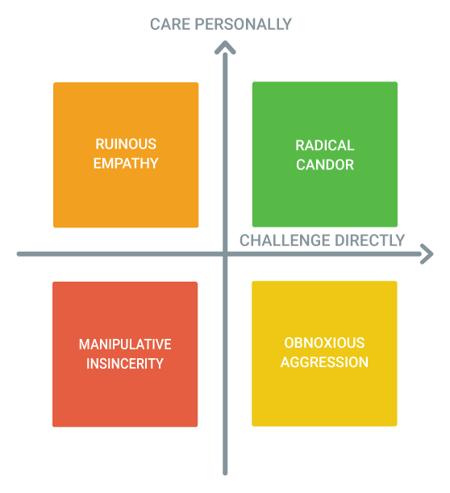
Radical Candor™ is the ability to challenge directly and show you care personally at the same time).
Obnoxious Aggression™ is what happens when you challenge but don’t care. It’s praise that doesn’t feel sincere or criticism that isn’t delivered kindly.
Ruinous Empathy™ is what happens when you care but don’t challenge. It’s praise that isn’t specific enough to help the person understand what was good or criticism that is sugarcoated and unclear.
Manipulative Insincerity™ is what happens when you neither care nor challenge. It’s praise that is non-specific and insincere or criticism that is neither clear nor kind.
https://www.radicalcandor.com/about-radical-candor/
  - Engage with those you disagree with. In this TED talk (link below), Megan Phelps-Roper explains how to positively engage with those whose world view is very different from yours. Can I encourage you to look beyond the content and to focus on the four steps she outlines:
    - Don’t assume bad intent
When we assume good or neutral intent we give our minds a much stronger framework for dialogue
    - Ask questions
It signals to someone that they’re being heard
    - Stay calm
This takes practice and patience, but it’s powerful
    - ‘Make the argument’ (explain the reasons behind your position)
We are all a product of our upbringing and our beliefs reflect our experience

https://www.youtube.com/watch?v=bVV2Zk88beY

- Practice forgiveness
It’s arguable, I think, that each of the practices outlined above are not exclusively expressions of Christian spirituality. What makes their practice distinctively Christian, I think, is that they are practiced in an atmosphere and environment of love (or ‘community’, incarnation (entering into another person’s world and seeing their world from their perspective), and, most of all, forgiveness. This enables us to leave past hurts behind, make things as right as they can be and embrace a deeper level of understanding and connectedness. In the world of human relationships, intention doesn’t guarantee performance, and in places like Poatina, if we are to relate honestly and harmoniously with one another, forgiveness will be vital.

Suggestions for reflection and discussion:
- What do you think of the idea that interpersonal communication is an important part of Christian spirituality?
- Could you recount any positive or negative experiences of the 6 practices outlined that you’ve had in Poatina?
- How do you find yourself responding to either or both of the frameworks for dealing with conflict
- Which of these practices do you think challenge you the most?
- Which of them do you feel drawn to?
- What kind of help do you think you will need to integrate any or all of these practices into your life and behaviour?
- What other interpersonal communication practices have you found helpful in expressing your spirituality?

Bruce Dutton, February 2018.

